Chapter 8, Problem 40.

The switch in the circuit of Fig. 8.88 is moved from position a to b at t = 0. Assume that the voltage across the capacitor is equal to zero at t = 0 and that the switch is a make before break switch. Determine i(t) for all t > 0.

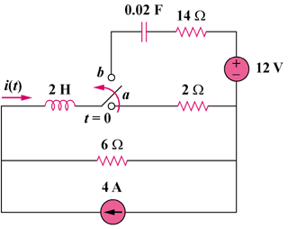

Figure 8.88
For Prob. 8.40.

